Question 1-)

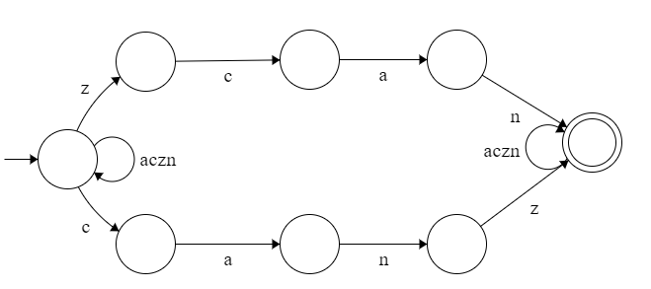

[cazn]\*("zcan"|"canz")[cazn]\*

Question 2-)  
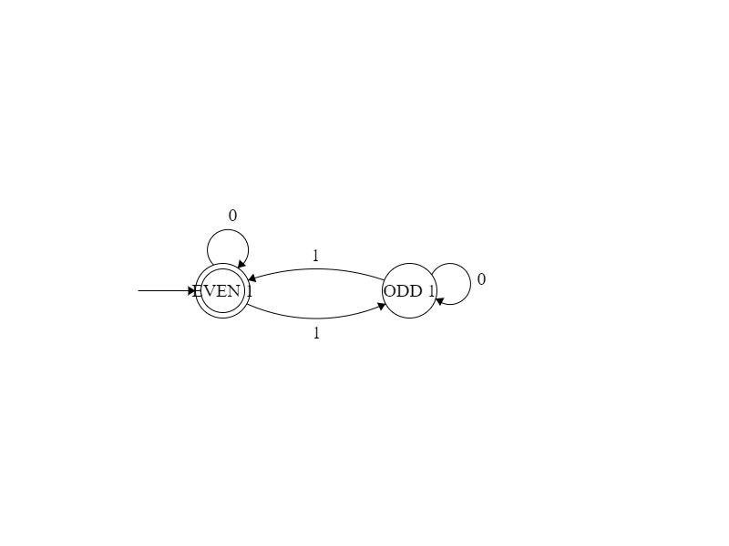

Question 3-)

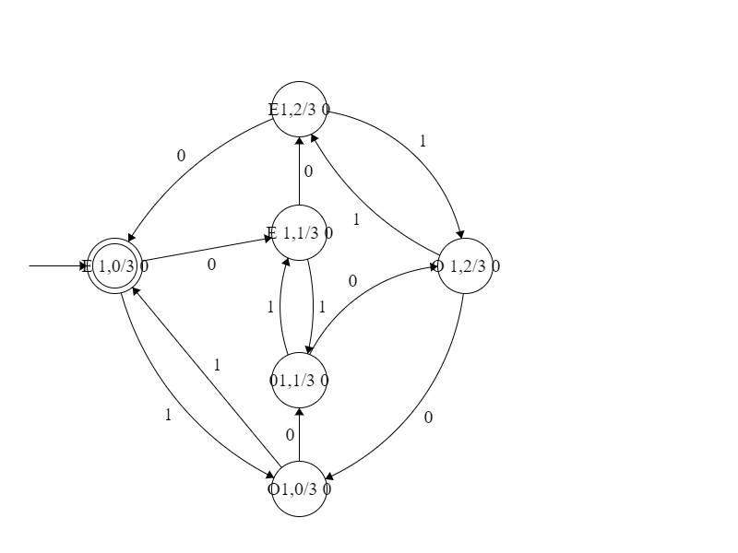

Question 4

days [1-9]|[1-2][0-9]|3[0-1]

digit [0-9]

letter [A-Za-z]

dataextension "nd"|"st"|"rd"|"th"

months "January"|"February"|"March"|"April"|"May"|"June"|"July"|"August"|"September"|"October"|"November"|"December"

{days}{dataextension}" of" {months}" "{digit}{1,4}